LCD Interfacing

* [Liquid Crystal Display](https://electrosome.com/lcd-display-fundamentals/) ([LCD](https://electrosome.com/lcd-display-fundamentals/)) is very commonly used electronic display module and having a wide range of applications such as calculators, laptops, mobile phones etc.
* 16×2-character LCD display is very basic module which is commonly used in electronics devices and projects.
* The most commonly used ALPHANUMERIC LCD displays are
* 1x16(single line &16 characters)
* 2x16(2 lines of 16 characters per line)
* 4x20(4 lines & Twenty characters per line)

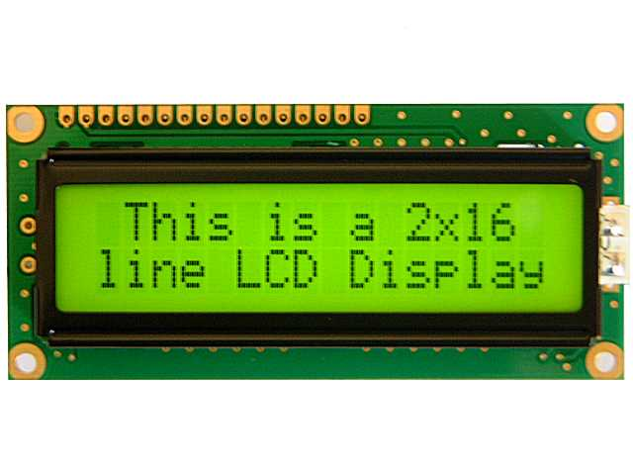

* The LCD requires 3 control lines (RS, R/W &EN) & 8 or 4 data lines.
* The number on data lines depends on the mode of operation.
* If operated in 8-bit mode then 8 data lines +3 control lines total 11 lines are required.
* And if operated in 4 –bit mode then 4 data lines +3 control lines i.e. 7 lines are required.
* If you have sufficient data lines you can go for 8-bit mode & if there is a time constrain i.e. display should be faster, then we have to use 8-bit mode because basically 4-bit mode takes twice as more time as compared to 8-bit mode.

|  |  |  |
| --- | --- | --- |
| **Pin No:** | **Name** | **Function** |
| **1** | **VSS** | This pin must be connected to the ground |
| **2** | **VCC** | Positive supply voltage pin (5V DC) |
| **3** | **VEE** | Contrast adjustment |
| **4** | **RS** | Register selection |
| **5** | **R/W** | Read or write |
| **6** | **E** | Enable |
| **7** | **DB0** | Data |
| **8** | **DB1** | Data |
| **9** | **DB2** | Data |
| **10** | **DB3** | Data |
| **11** | **DB4** | Data |
| **12** | **DB5** | Data |
| **13** | **DB6** | Data |
| **14** | **DB7** | Data |
| **15** | **LED+** | Back light LED+ |
| **16** | **LED-** | Back light LED- |

* The LCD Controller has two built in registers namely data register and command register.
* Data register is for placing the data to be displayed, and the command register is to place the commands.
* When RS is low (0), the data is to be treated as a command.
* When RS is high (1), the data being sent is considered as text data which should be displayed on the screen.
* If we make RS pin low and put a data on the data line, the module will recognize it as a command.
* R/W pin is meant for selecting between read and write modes. High level at this pin enables read mode and low level at this pin enables write mode.
* E pin is for enabling the module. A high to low transition at this pin will enable the module.
* DB0 to DB7 are the data pins. The data to be displayed and the command instructions are placed on these pins.
* LED+ is the anode of the back light LED and this pin must be connected to Vcc through a suitable series current limiting resistor.
* LED- is the cathode of the back light LED and this pin must be connected to ground.
* **16×2 LCD module commands.**
* 16×2 LCD module has a set of preset command instructions.
* Each command will make the module to do a particular task.
* The commonly used commands and their function are given in the table below.

|  |  |
| --- | --- |
| Command | Function |
| 0F | LCD ON, Cursor ON, Cursor blinking ON |
| 01 | Clear screen |
| 02 | Return home |
| 04 | Decrement cursor |
| 06 | Increment cursor |
| 0E | Display ON ,Cursor blinking OFF |
| 80 | Force cursor to the beginning of  1st line |
| C0 | Force cursor to the beginning of 2nd line |
| 38 | Use 2 lines and 5×7 matrix |
| 83 | Cursor line 1 position 3 |
| 3C | Activate second line |
| 08 | Display OFF, Cursor OFF |
| C1 | Jump to second line, position1 |
| OC | Display ON, Cursor OFF |
| C1 | Jump to second line, position1 |
| C2 | Jump to second line, position2 |

#### LCD initialization.

The steps that has to be done for initializing the LCD display is given below and these steps are common for almost all applications.

* Send 38H to the 8-bit data line for initialization
* Send 0FH for making LCD ON, cursor ON and cursor blinking ON.
* Send 06H for incrementing cursor position.
* Send 01H for clearing the display and return the cursor.

#### Sending data to the LCD.

The steps for sending data to the LCD module is given below. LCD module has pins namely RS, R/W and E. It is the logic state of these pins that make the module to determine whether a given data input is a command or data to be displayed.

* Make R/W low.
* Make RS=0 if data byte is a command and make RS=1 if the data byte is a data to be displayed.
* Place data byte on the data register.
* Pulse E from high to low.
* Repeat above steps for sending another data.

### Circuit diagram.

[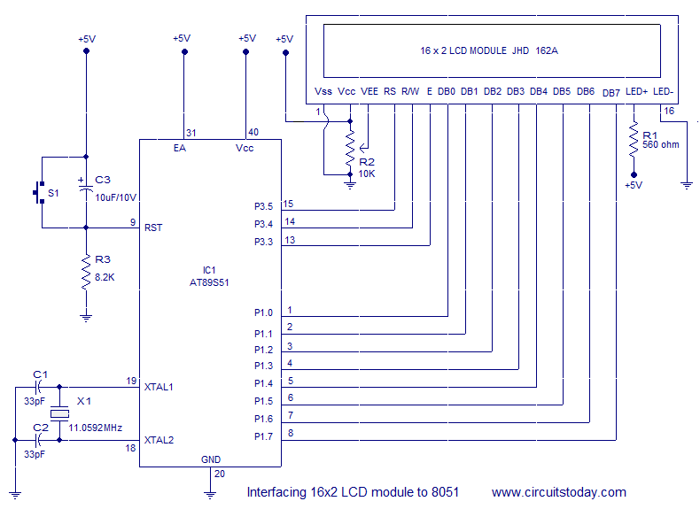](http://www.circuitstoday.com/wp-content/uploads/2012/06/interfacing-16x2-LCD-to-8051.png)

* Interfacing 16×2 LCD module to 8051
* The circuit diagram given above shows how to interface a 16×2 LCD module with AT89S1 microcontroller.
* P1.0 to P1.7 pins of the microcontroller is connected to the DB0 to DB7 pins of the module respectively and through this route the data goes to the LCD module.
* P3.3, P3.4 and P3.5 are connected to the E, R/W, RS pins of the microcontroller and through this route the control signals are transferred to the LCD module.